**CODE QUEEN HACKATHON**

**TEAM 1 COHORT 8**

**2023**

DEVELOPING AN E-SAVING WEBSITE FOR THE YOUTH.

(CASE STUDY: TUBAYO COMMUNITY FUND)

By

|  |  |  |
| --- | --- | --- |
| Name |  | Phone Number |
| Mugenyi Brenda |  | +256 758524934 |
| Nakisanze Deziranta |  | +256 786191990 |
| Namayanja Linda |  | +256 709765709 |
| Nalupo Christine |  | +256 775922166 |
| Nanyonjo Sharon |  | +256 788190835 |
| Nalukwago Hadija |  | +256 771062805 |
| Nassuuna Swabra |  | +256 758919919 |

Supervised by

Ms. Apolat Diana

Code Queen

# **DECLARATION**

We, the undersigned, declare that to the best of our knowledge, this proposal is our original piece of work, and has never been published and/or submitted for any award in any organization or any other university or Higher institution of Learning.

|  |  |  |
| --- | --- | --- |
| Name | Phone Number | Signature |
| Mugenyi Brenda | +256 758524934 |  |
| Nakisanze Deziranta | +256 786191990 |  |
| Namayanja Linda | +256 709765709 |  |
| Nalupo Christine | +256 775922166 |  |
| Nanyonjo Sharon | +256 788190835 |  |
| Nalukwago Hadijja | +256 771062805 |  |
| Nassuuna Swabrah | +256 758919919 |  |

Date…………………………………….

# **APPROVAL**

This proposal has been submitted with my approval as supervisor and my signature is here appended:

Signed………………………… Date……………………….

Ms. Apolat Diana

Code Queen

A RESEARCH PROPOSAL SUBMITTED TO CODE QUEEN IN PARTIAL FULFILLMENT OF THE AWARD OF SOFTWARE DEVELOPMENT.

Table of Contents

**DECLARATION** 2

**APPROVAL** 3

**ABSTRACT** 6

CHAPTER ONE 7

**1. Introduction** 7

**1.1 BACKGROUND OF STUDY** 7

**1.2 STATEMENT OF PROBLEM** 7

**1.3 OBJECTIVES OF STUDY** 8

**1.4 SCOPE OF STUDY** 8

**1.4.1 About the E-saving website** 8

**1.4.2 The E-saving website and the services offered there** 8

**1.4.3 Online saving** 8

**1.4.4 Type of services sold.** 8

**1.5 SIGNIFICANCE OF STUDY** 8

**1.6 LIMITATIONS** 9

CHAPTER TWO 10

**2. LITERATURE REVIEW** 10

**2.1 INTRODUCTION** 10

2.2 IMPORTANCE OF E-SAVING 11

2.3 WHY YOU SHOULD CHOOSE AN E-SAVING SYSTEM 11

2.4 conclusion 12

CHAPTER THREE 13

**3 METHODOLOGY AND SYSTEM ANALYSIS** 13

**3.1 RESEARCH METHODOLOGY** 13

**3.2 METHODS OF DATA COLLECTION** 13

**3.3 STUDY OF MANUALS** 13

**3.4 EVALUATION OF FORMS** 13

**3.5 ANALYSIS OF EXISTING SYSTEM** 13

**3.6 OBJECTIVES OF THE PROPOSED SYSTEM** 14

**3.7 JUSTIFICATION FOR THE NEW SYSTEM.** 14

CHAPTER FOUR 16

**4 SYSTEM DESIGN, IMPLEMENTATION AND TESTING** 16

**4.1 DESIGN STANDARD** 16

**4.2 OUTPUT SPECIFICATION** 16

**4.3 INPUT SPECIFICATION** 16

**4.4 DATABASE SPECIFICATION** 16

**4.5 CHOICE OF PROGRAMMING LANGUAGE** 17

**5 System presentation** 17

CHAPTER FIVE 22

**6 SUMMARY, CONCLUSION AND RECOMMENDATIONS** 22

**6.1 SUMMARY** 22

**6.2 CONCLUSION** 22

**6.3 RECOMMENDATIONS** 22

**6.4 REFERENCES** 23

# **ABSTRACT**

In modern times E-commerce plays a vital role in the activities of a business. The main aim of this proposal was to build and develop a reliable website based on e-commerce theories, designing well designed web pages. This website will be able to enable youth save their money with the system . To achieve this online website we used current technologies for example HTML, CSS, JavaScript etc. At first stage we set up an online interface with maximum usability and then improved on customer experience and lastly implement mobile money payment methods to enable direct saving between an individual to the system .

# CHAPTER ONE

# **1. Introduction**

This section of the research proposal presents the background of the study, problem statement and purpose of the study, significance of the study and the scope of the study.

## **1.1 BACKGROUND OF STUDY**

(COPY AND PASTE OUR BACKGROUND STUDY)

## **1.2 STATEMENT OF PROBLEM**

As the economy in Africa is growing, people are seeking for more ways to become financially stable and independent especially the youth with much ease and still maintain the standard of living, invest and accumulate wealth. The youth need to save their money their money, daily, weekly ,monthly or even yearly in order to be financially independent and liberal in their old age. The manual method of going to their remote and physical saving financial institutions to save is becoming obsolete and more tasking. Depositing savings can be done through the internet without going to the financial institutions. So there is need for a wide range of publicity and enabling direct saving, processing through an online system. For this system, there will be a system administrator who will have the rights to enable the end user track saving progress, help users set their financial goals, offer various investment opportunities, provide financial literacy education to the end user.

## **1.3 OBJECTIVES OF STUDY**

This study lays out a framework for a new system to be developed and brought to the market for maximum use and to create an avenue through the web where users can log on to our server and make a selection of our features modules that is to say, tracking financial goals, savings progress, view various investment opportunities as well as get an insight to financial literacy and subsequently deposit through mobile money then to the system. The following are the objectives that can be displayed:

1. The home page of this web interface provides an avenue where the youth and other end users will be able to gather more and reliable information about E-saving and financial literacy

2. The services offered would provide the customers with all the different categories of available saving methods they can choose and select from and still earn their daily, weekly or monthly income.

3. This will provide a user friendly way for the youth to conveniently and accessibly save and invest their money thus achieving their financial goals hence promoting economic growth and development within and outside the country through the E-saving system.

4. There will also be an online support customer care team form with which valued customers will be using to get in touch with any of their request whenever the need arises(editable)

5. It will also help for easy retrieval of savings made by the customers.

## **1.4 SCOPE OF STUDY**

In this project, an E-saving website is designed and Tubayo Community Fund is taken as a case study to enable youth and other end users save their money and at the same time still maintain a standard of living at their convinience. The following things are among other things that are discussed and what the software would handle:

## **1.4.1 About the E-saving website**

The research we are looking at is mainly for an online system for Tubayo Community Fund and we are mainly going to be confined on designing and developing it.

## **1.4.2 The E-saving website and the services offered there**

We are going to look at the financial services sold and offered by the website sells and design it according to the nature of the savings problem faced among the youth.

## **1.4.3 Online saving**

Incorporating an online payment system to enable customers or clients save their money at the convenience of their geographical location will be in our best interests.

## **1.4.4 Type of services sold**

Financial services are going to be sold basically inform of promoting savings among the youth in Uganda.

## **1.5 SIGNIFICANCE OF STUDY**

In view of the rapid development of computer technology in almost all the fields of operation and its use in relation to information management, it has become important to look into the development of online saving system for youth to enable them save and still earn income. Therefore, the E-saving system will help customers and management to:

1. Set financial goals

2. Track saving progress.

3. Provide financial literacy

4. Provide various investment opportunities for the youth.

## **1.6LIMITATIONS**

Due to time and financial constraints, the software that is developed covers only the aspect of saving and payments.

# CHAPTER TWO

# **2. LITERATURE REVIEW**

## **2.1 INTRODUCTION**

Saving refers to income not spent or deferred consumption. Saving can be done online or manually. This helps the customer to save their money themselves which is known as the customer self-saving system. The customer self-saving system can be defined as a computerized system that is being used by customers to deposit their money inform of savings or in groups for either a short or long term period of time to the Tubayo Community Fund and allow the savings to be tracked, in order and achieve financial goals of the different individuals.

# 2.2 WHY YOU SHOULD CHOOSE AN E-SAVING SYSTEM

According to WERONIKA KUZIOR (2022) in the current generation business are expected to be online with the ubiquitous access to the internet, an average youth does online research before purchasing a product or looking up a brand online and checking reviews is basically a standard. An e-saving website practically plays the role of the finance window, drawing the attention of customers and presenting the business to the world. Some of the reasons why a young person should choose the Tubayo Community Fund

1. Geographical convenience to deposit savings
2. Financial security of savings
3. Improved customer care and interactivity
4. Minimum savings deposits
5. Financial literacy
6. Easily track their saving progress and financial statements.
7. Specialised for the youth and user friendly.

# 2.6 PROCESS OF WEBSITE DESIGN

MATT MEAZEY (2020) Web designers often think about the web design process with a focus on technical matters such as code and content but great design isn’t about all this but how you design a website that aligns with an overarching strategy

1. Goal identification

The initial stage is all about understanding how you can help your client

1. Scope identification

This provides an invaluable reference for both designers and company and helps keep everyone focused on the task and goals at hand

1. Sitemap and wireframe creation

This provides the foundation for any well-designed website. It helps give a clear idea of the websites information architecture and explains relationships between the various pages and content

1. Content creation

This drives engagement and action from the users of the website

1. Visual elements

This part of the design process will often be shaped by existing branding elements that enhance engagement from users

1. Testing

Once the site has all its visuals and content, you’re ready for testing

1. Launch

When everything has been thoroughly tested, it’s time to launch

# 2.7 conclusion

Website design is not always a simple process depending on the type of website you are creating but in our case we are focusing on an E-saving website and our main areas of concern are website saving, payment integration and usability of the website.

# CHAPTER THREE

# **3 METHODOLOGY AND SYSTEM ANALYSIS**

## **3.1 RESEARCH METHODOLOGY**

Research methodology has many research dimensions and methods. The scope of research methodology is wider than research method. This is mainly adopted by the researcher in undertaking this research. Methodology is the underlying principles and rules that govern a system method, on the other hand it is a systematic procedure for a set of activities. Thus, from these definitions a methodology encompasses the methods used within a study.

A waterfall model under the software development life cycle (SDLC) is the methodology used to produce the online saving system and the customer self-self system. It is used by system developers to produce or alter information systems or software. It divides the development process into several stages or processes. After the completion of one stage, it will logically move to another stage. Sometimes moving back to the previous stage is necessary due to failure that occurs in current stage. System design methods are a discipline within the software development industry which seeks to provide a framework for activity and the capture, storage, transformation and dissemination of information so as to enable the economic development of computer systems that are fit for purpose.

# **3.2 METHODS OF DATA COLLECTION**

## **3.3 STUDY OF MANUALS**

Manuals and report based on E-saving were obtained and studied and a lot of information concerning the system to be produced was obtained.

## **3.4 EVALUATION OF FORMS**

Some forms that are necessary and available were accessed. These includes the saving details on the market, deposit and withdraw receipts etc. these forms helped in the design of the new system.

## **3.5 ANALYSIS OF EXISTING SYSTEM**

Throughout the system analysis, an in-depth, study of end-user information is conducted, for producing functional requirement of the proposed system. Data about the existing saving system is collected through several fact-finding techniques such as website visit and document review, at the beginning of this stage. The data collected facilities information required during detailed analysis. A study on the current system is performed based on the collected data. As a result, user requirement of the proposed system are determined. At the end of this stage, requirement specification is produced as deliverable.

## **3.6 OBJECTIVES OF THE PROPOSED SYSTEM**

The proposed system is developed to promote a saving culture among young people in Africa. It helps to record saving deposits of the youth. The system should cover the following functions in order to support the saving process for achieving the objectives:

1. To track the saving progress of the youth in the different membership types and enable them save by making deposits through mobile money and still earn income thereby promoting a saving culture.

2. To enable the youth set their financial goals to be achievable within a given period of time.

3. To improve on the financial awareness and literacy among the youth.

4. To provide various investment opportunities for the youth.

## **3.7 JUSTIFICATION FOR THE NEW SYSTEM.**

This system will do the analyzing and storing of information either automatically or interactively. It will make use of JavaScript. This will be like this: a report is generated conforming to particular information needed by the management via the monitor. This will require the input of necessary data and record of savings and then a report is generated. The proposed system will also have some other features such as:

1. Accuracy in handling of data

2. The volume of paper work will be greatly reduced.

3. Fast rate of operation as in making the ordered food available and delivered on time.

4. Flexibility (i.e. it can be accessed at any time)

5. Easy way to back up or duplicating data in CD’s in case of data loss

6. Better storage and faster retrieval system

7. Errors in the reports will be greatly minimized

# CHAPTER FOUR

# **4 SYSTEM DESIGN, IMPLEMENTATION AND TESTING**

## **4.1 DESIGN STANDARD**

The system is designed with several interaction cues on each web page that makes up the web application. These cues are well-defined such as to make several functionality that the application exposes to collect, process and output data. Access to these functionalities is made possible by the well-designed user interface which embodies several technologies such as HTML, CSS and JavaScript to process data. The application is built in a modular form where these functionalities are built into modules. Some of the modules are as follows:

1. Login

2. Menu

3. (EDITABLE)

**4.2 OUTPUT SPECIFICATION.**

The system is designed in such a way that it efficiently provides output to the user promptly and in a well-organized manner. The format for the several output are make available on the output web pages. Output can be relayed using the following page modules:

1. Saving list: This display output information for the list of saving types which are currently available

2. Search result: This displays output information for the saving report

3. about us: This displays output information that talks about the saving type.

**4.3 INPUT SPECIFICATION.**

The system is designed to accept several input details efficiently through input forms and user clicks. The data captured through the user keystrokes and clicks are received by specific modules on the system and relayed to the back-end of the system for processing. Input is collected using the following page modules:

1. Index.html: This is used to capture preliminary user navigation information and preference information which gives the system a method of personalizing the page for the user on the next visit.

2. Admin_login: This is used to capture information about the administrative personnel who controls content and display on the system.

**4.4 DATABASE SPECIFICATION**.

The database system used to implement the back-end of the system is JavaScript frame work. Access to the system was made possible by a graphical interface with and Vue.js. The database name is Tubayo Community Fund.

## **4.5 CHOICE OF PROGRAMMING LANGUAGE**

So many programming languages were put into consideration in the cause of designing this software. A lot of factors were also considered which includes the online database access, data transmission via networks, online database retrieval, online data capture, multi user network access database security, etc. Enquiry 27 the database system used to implement the back-end of this system is Mongodatabase and php. Mongodatabase is a robust database that can guarantee database integrity, database protection and accommodate large database. Access to the system was made possible by a graphical interface (phpMyadmin) with an ISAM engine. The phpMyadmin is very user friendly and can be modified programmatically. On the Front end we decided to use HTML, CSS and JavaScript.

## **5 System presentation**

5.1 Sample code.

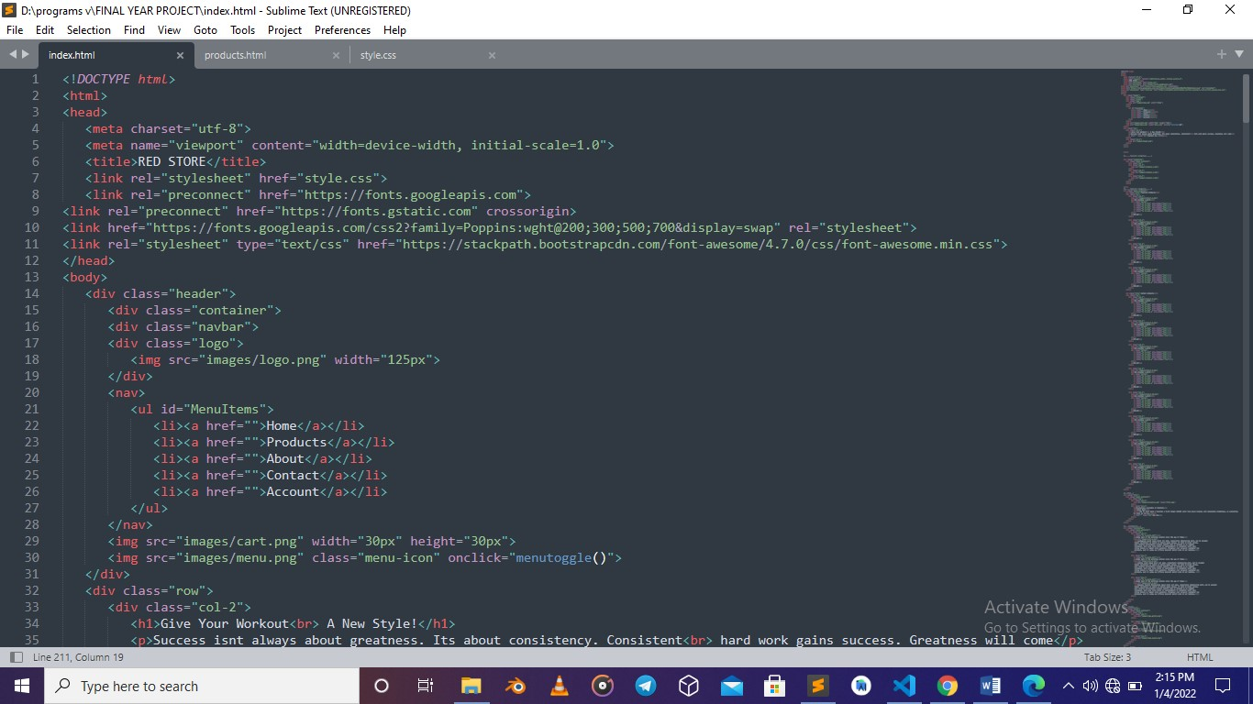

5.2 Screenshots from website.

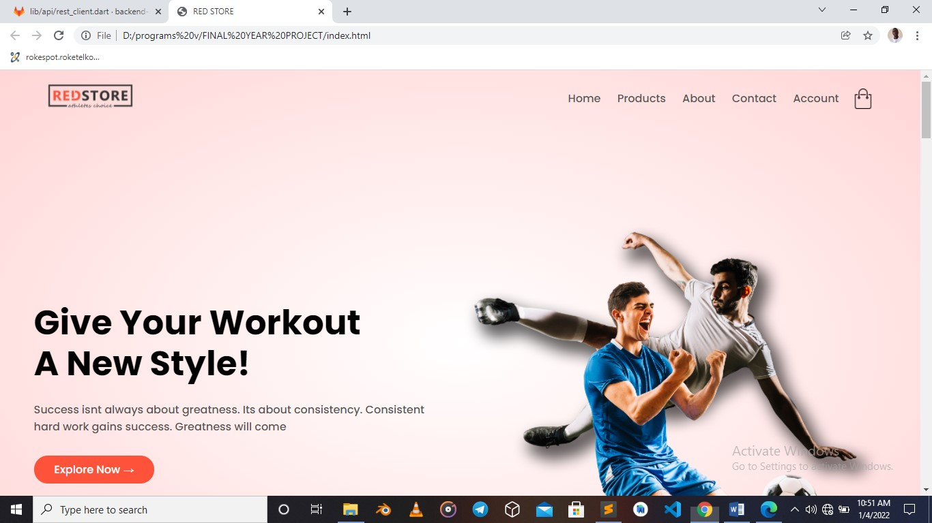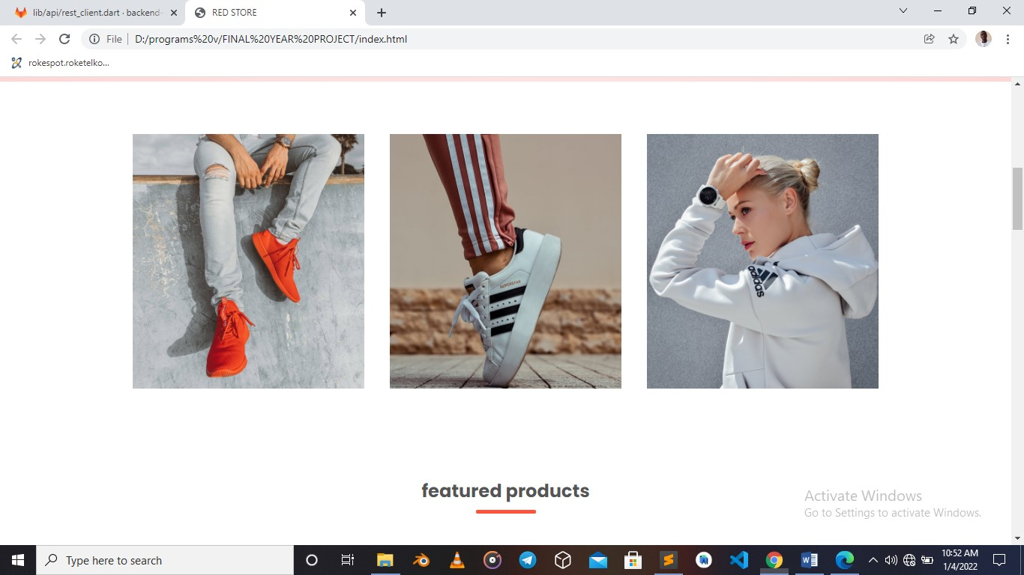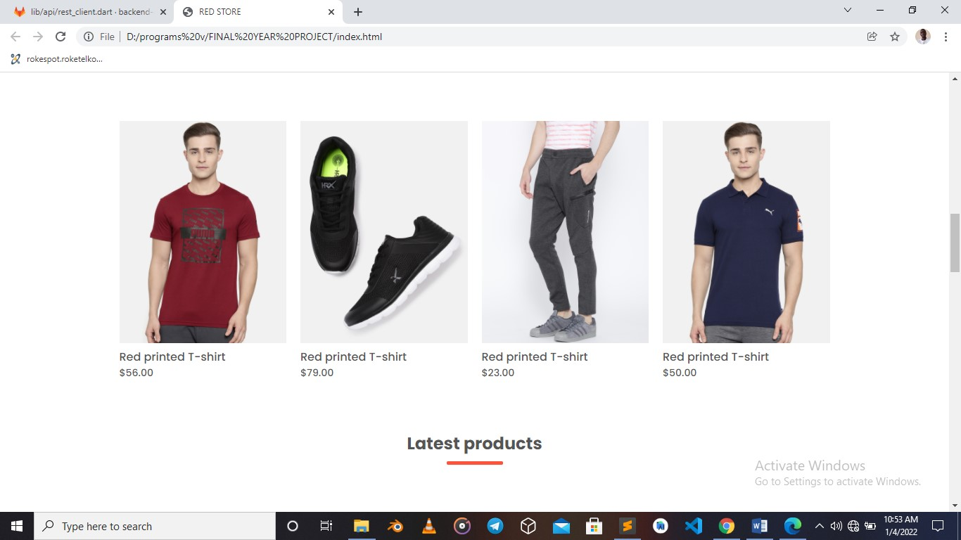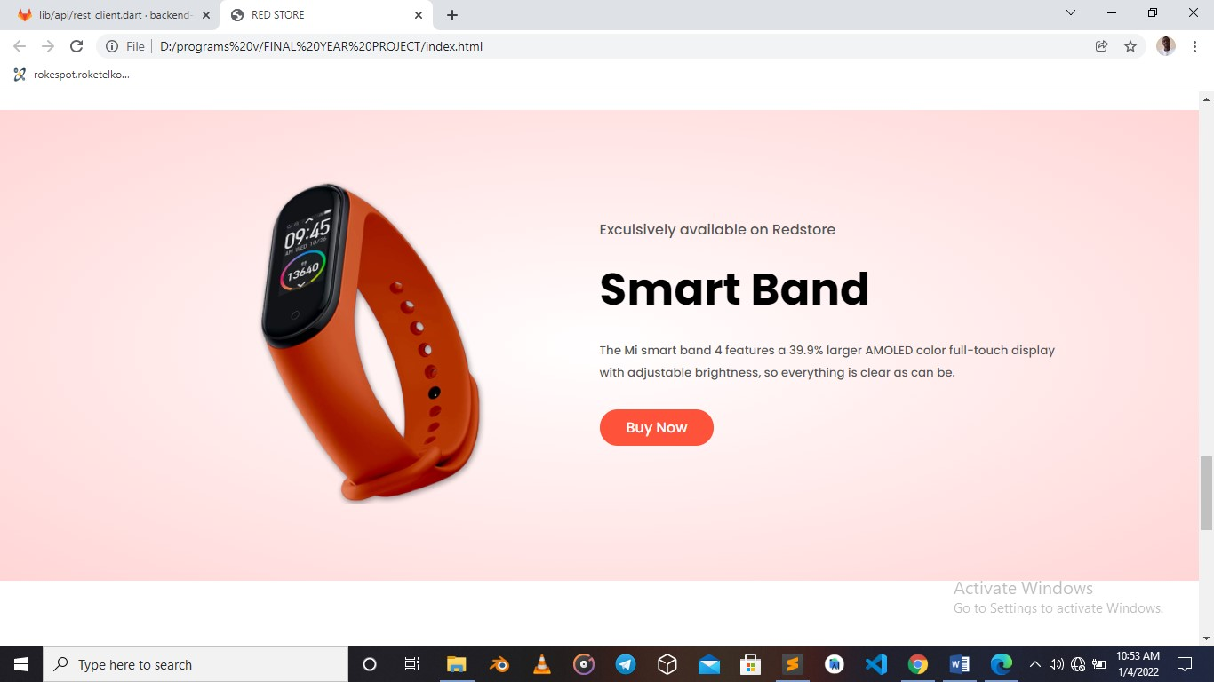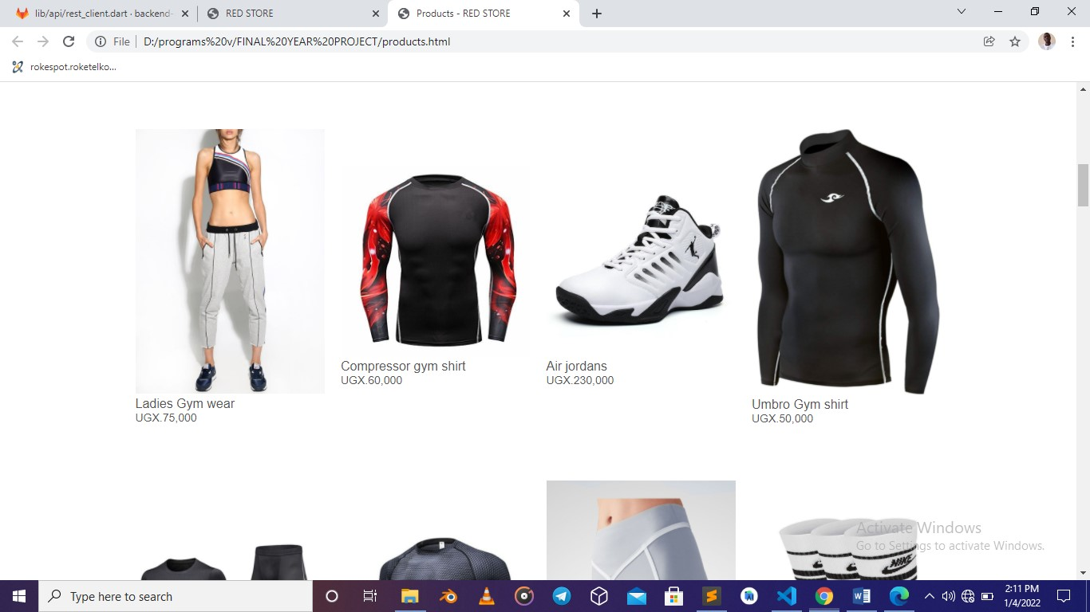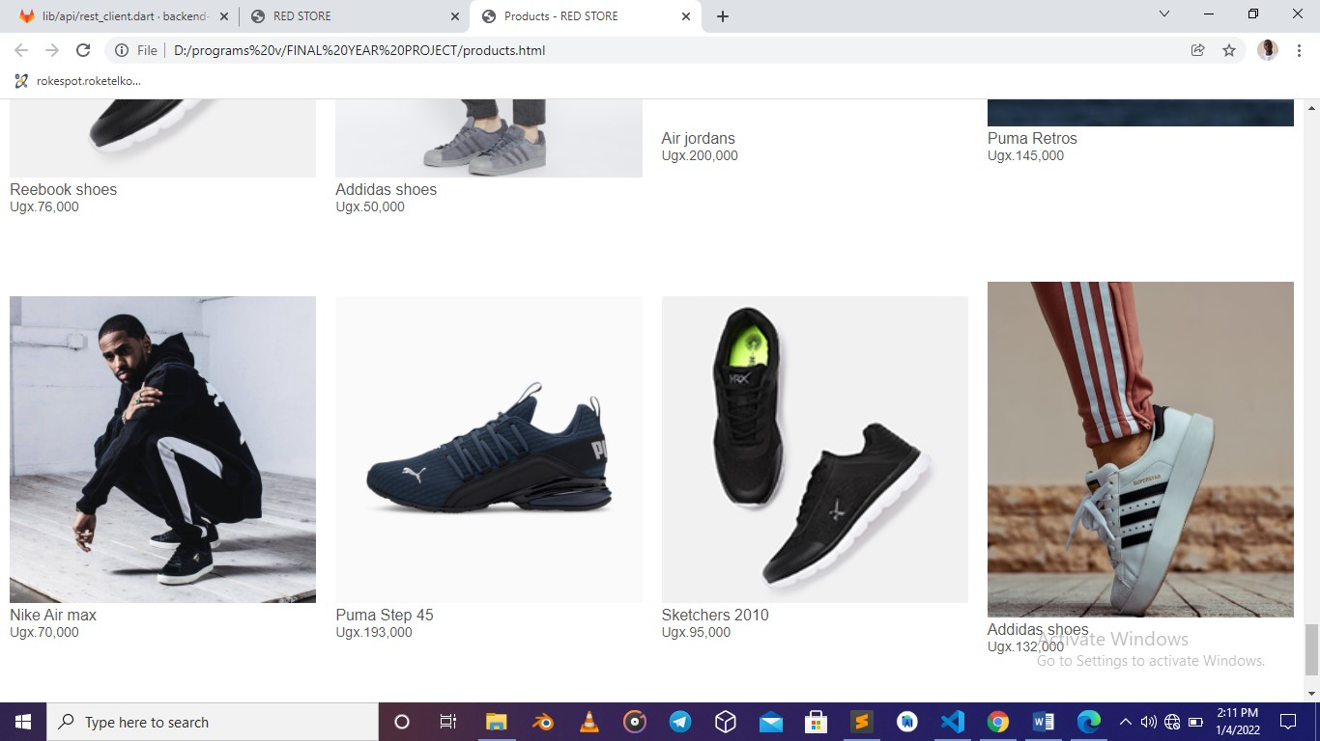

# CHAPTER FIVE

# **6 SUMMARY, CONCLUSION AND RECOMMENDATIONS**

## **6.1 SUMMARY**

At the end of this project work, we should be able to design and develop software that can successfully handle an online saving system for Tubayo Community Fund. This work also will serve as a stepping-stone for people who wish to research more on this topic. Other benefits are:

1. Provision of facility for handling text electronically using powerful and sophisticated word processors to produce elegant and error free documents.

2. In addition to storing the organization’s operational data on disk backing storage, other forms of data used by the organization could also benefit from storage on such medium.

3. With the installed software, a saving culture is made easier by the youth. The systematic approaches used during each phase of the software development provides a clear road map that would be of immense help to anyone carrying out research work in this area.

## **6.2 CONCLUSION**

The development of an E-saving system involved many phases. The approach used is a top-down one concentrating on what first, then how and moving to successive levels of details. In the course of this study, many problems were discovered to have hindered the effectiveness of the existing manual system. These problems, information needs and activities were documented and later used as the basis for system design, which immediately followed the first phase. The design phase was concerned primarily with the specification of the system elements in manner that best met the organization’s business needs.

During this phase, strict adherence was made on proven software engineering principles and practices. To implement this design, a computer program was then written and tested in JavaScript. It is hoped that effective implementation of this software product would eliminate many problems discovered during systems investigation.

## **6.3 RECOMMENDATIONS**

It is known that for any meaningful computer based information management to be integrated into any organization, proper training and orientation has to be given both to the staff and management. Proper training should be given to the data entry staff on how to handle the computer hardware especially during backup processes. In particular, electronic storage media are usually sensitive to change in temperature or pressure and as such, data can be lost very easily. The staff should also be highlighted on the need and advantage of the system and how it will equally assist them in their various field of work. They should also be informed of the cost of maintaining this new system so that they will handle it with all carefulness. Training materials should not be presented in formal way but with procedures like policies and form etc. They should be circulated to the personnel. This will at the end generate appreciation and needed interest to operate the system.

## **6.4 REFERENCES**

Anderson, R.G. (1978), “Data processing and Management Information Systems” McDonald and Evans Ltd

Albert H, Judd, Rivers, (2006) “Creating a winning E-business”, Wagner course Technology Thompson learning, pp. 37-255.

David W, (2001) “E-commerce strategy, Technologies and Applications”, Tata McGraw Hill, pp.3-143

Kalakota, R and Robinson M (1999), “E-business: Roadmap for success”,

Addison- Wesley, 112-149

Namita.R (2011). “Global Journal of Enterprise Information system”, Vol. 3,

No.1, PP. 17-31

Chapman, C (2019) . The ultimate guide to designing ecommerce websites retrieved 30th/01/2016 from <http://www.webdesignerdepot.com/2019/06/the-ultimate-guide-to-designing-ecommerce-websites/>

Mwesiga, A. (2019) E-commerce takes root in Uganda retrieved 8/2/2016 From <http://www.observer.ug/business/38-business/35400--e-commerce-takes-root-in-uganda>

MacDonald, B. (2011) 4 Reasons Your store Needs an ecommerce Website to Grow Retrieved from http://blog.hubspot.com/blog/tabid/6307/bid/8388/4-Reasons-Your-Store-Needs-an-eCommerce-website-to-Grow-aspx

Mobile savings app: Develop a mobile application that enables young people to set savings goals and make regular contributions towards them. The app could also provide financial education, tips, and tools to help users manage their finances and make informed decisions.

Online financial literacy platform: Create an online platform that offers financial literacy courses, workshops, and resources tailored to the needs of young people in Africa. The platform could cover topics such as budgeting, saving, investing, and managing debt.

Digital savings group: Establish a digital savings group that allows young people to pool their resources and collectively save towards a shared goal. The group could use a mobile app or online platform to facilitate communication, contributions, and monitoring of progress.

Virtual financial coaching: Provide virtual financial coaching services to young people in Africa through a mobile app or online platform. The coaching could include personalized advice and guidance on financial planning, saving, and investment strategies.

Gamified savings app: Create a mobile app that gamifies the savings process and incentivizes young people to save more. The app could offer rewards, challenges, and social features to encourage users to save regularly and compete with friends.

Out of these ideas, the best one would depend on the specific needs and preferences of the target audience. However, considering the challenge requirements and the current situation in Africa, the mobile savings app could be a promising solution. This is because it addresses the issue of limited access to formal financial services, provides financial education, and leverages technology to make savings more accessible and manageable for young people.